Status CPLD Release Note

1. Folder Structure

SRC --- source code, including Verilog file and Constraint file.

SIM --- simulation code, including testbench and do file.

BLD --- project file

1. Code Structure

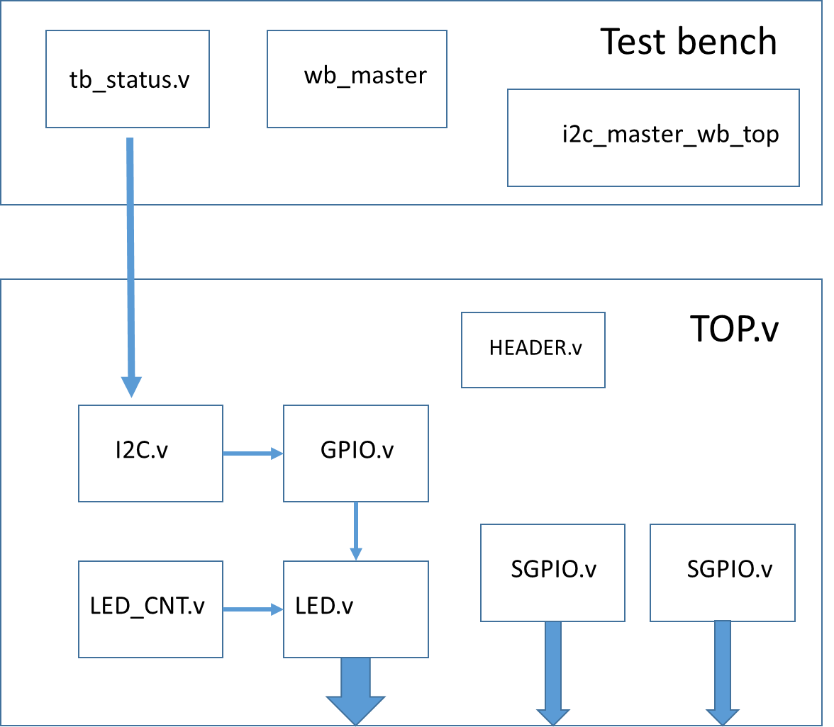

1. Simulation

tb_status.v is the simulation top file, you can change the test flow in this module. There are five task in testbench including SGPIO, HEADER_TEST, LED_TEST, wb_write and wb_read.

About do file, there are two do file including tb_status.do and status_wave.do. The tb_status.do is for compile and the status_wave.do is only for waveform.

1. Project Build

All the project file is located in BLD folder, and the Status.ldf is for diamond.